**In-Depth Sales Performance Analysis: Key Insights and Strategic Recommendations for Revenue Growth**

**Introduction**

**Objective:**

The purpose of this analysis is to gain insights into the sales performance of a fictitious company from January 2014 to June 2015. The key objectives are to understand trends in revenue, evaluate the contribution of different lines of business across various regions, and identify potential areas for improvement. These insights aim to guide the company’s strategic decisions, improve sales efficiency, and optimize revenue generation by providing actionable data that can inform resource allocation, marketing strategies, and inventory management.

**Dataset Description:**

The dataset includes detailed sales transaction data from January 2014 to June 2015, capturing various aspects of sales across different regions and markets. The key variables include:

- **Region and Market:** Geographical areas where the sales were made.

- **Store:** Specific locations within the markets.

- **Trade Date and Fiscal Period:** Dates of sales transactions.

- **Model and Line of Business:** Types of products or services sold.

- **Revenue and Units Sold:** Financial and quantity metrics of the sales.

- **Performance Category:** Trades categorized into Small, Medium, Large, and Extra Large based on revenue.

Categorizing trades helps in understanding market segmentation, which is crucial for tailoring sales strategies to different market conditions. This dataset provides a comprehensive view of the company’s sales activities, allowing for in-depth analysis of revenue distribution, sales trends, and market performance across different regions.

**Data Cleaning and Preparation**

No missing data was found in the dataset. However, additional columns were created to facilitate the analysis:

**- Month:** Extracted from the date column to allow for monthly analysis.

**- Performance Category:** Trades were categorized based on their revenue into four categories:

1. Extra Large: Trades of ₦30 million and above
2. Large: Trades of ₦10 million and above
3. Medium: Trades of ₦2.5 million and above
4. Small: Trades below ₦2.5 million

**Analysis and Findings**

**Revenue Analysis:**

Two pivot tables were used in this analysis:

1. The first pivot table extracted the regions and revenue to assess the contribution of various lines of business to the company's overall revenue.
2. A second pivot table was used to extract the months and revenue, and calculate the month-on-month percentage change in revenue, visually represented with a line graph.

Key Questions:

1. What is the contribution of the various lines of business to the company's revenue?
2. How does each line of business contribute to the revenue in different regions?
3. What is the market share of each line of business within each region?
4. What is the overall Trend of Revenue?

Findings:

The analysis revealed that the Service Plan line of business contributes the highest portion of the overall revenue in every region, making it the biggest contributor to the company's total revenue. Specific insights include:

* **Copper Sales:** The North East region contributed the highest share (29.19%).
* **Parts Sales:** The South West region had the largest share (24.72%).
* **Printer Sales:** The North East region also led in this category (31.63%).
* 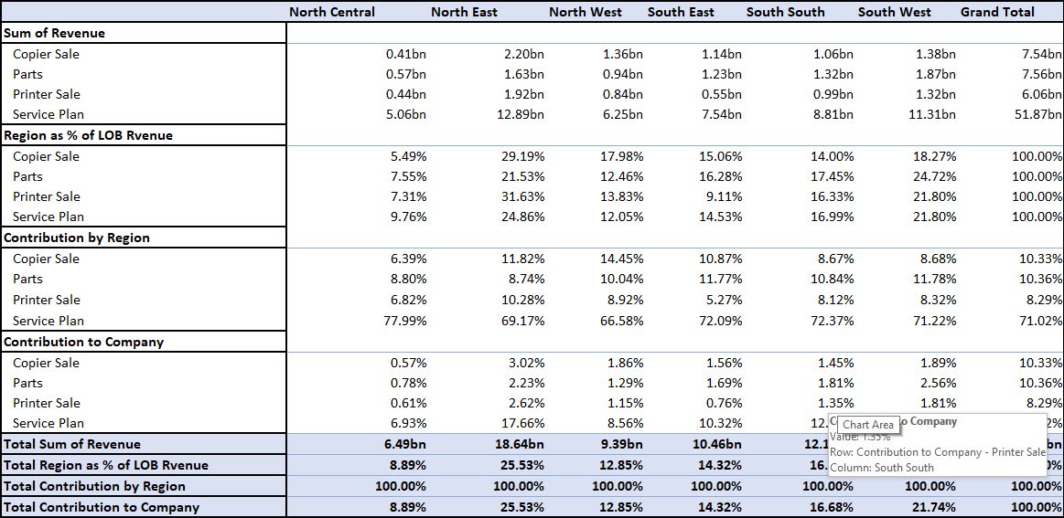**Service Plan:** The North East region had the highest contribution (24.86%).

Overall, the North East region generated the most revenue, with ₦18.64 billion, while the North Central region contributed the least, with just ₦6.49 billion.

The analysis also revealed fluctuations in revenue from January 2014 to June 2015. There were consistent revenue drops in 2014, with the steepest decline of 4.01% occurring in June. The first quarter of 2015 showed a sharp contrast, with a significant 5.94% drop in April following a peak in March. These fluctuations may be influenced by seasonal factors, promotional activities, or market conditions, which require further investigation.

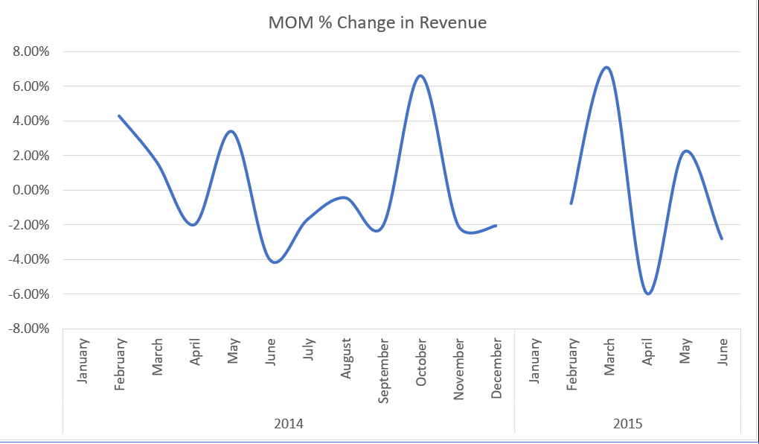

**Market Performance by Trade Size:**

Pivot tables were used to analyze the markets and the count of trades, filtering each table to provide information for each category:

1. Extra Large Trades: Kogi, Abia, and Sokoto markets led in this category, with the majority of trades occurring in the Service Plan line of business.
2. Large Trades: Abia topped the list with 147 trades, while Imo lagged behind with only 3 trades.
3. Medium Trades: Ekiti was the standout performer with 498 trades, while Ogun recorded the lowest number at 150.
4. Small Trades: The majority of trades were concentrated in the Small category, with Imo leading (1,616 trades) and Kogi trailing (513 trades).

**Model Analysis:**

A pivot table was used to extract the sum of units sold for all models, which was then represented using graphs:

The 3002C model had the highest units sold (205,710), while the 3002P model generated the most revenue (₦26.21 billion). The North East region recorded the highest units sold across all models, while the North Central region had the lowest.

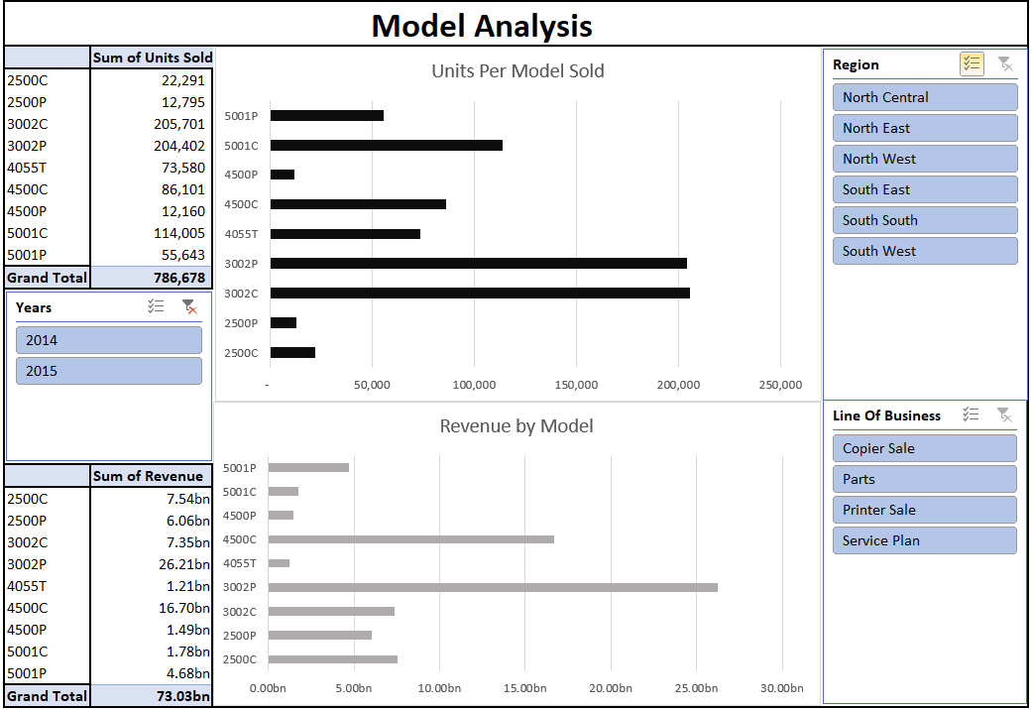

**Correlation Analysis:**

A correlation matrix and scatter plot were created using the CORREL function:

A weak positive correlation was found between the number of units sold and revenue, indicating that an increase in units sold tends to slightly boost revenue. This suggests that focusing on increasing sales volume could be a viable strategy for revenue growth. However, an outlier was identified, where a single trade of 244 units of the 4500C model generated ₦53.94 million, indicating that high-value trades can have a disproportionate impact on revenue.

**What-If Analysis:**

Four scenarios were simulated to explore potential revenue outcomes:

1. Scenario 1: A 2% increase in units sold across all models.
2. Scenario 2: A 6% reduction in units sold of the 2500C and 2500P models, with a corresponding 15% increase in 5001P.
3. Scenario 3: A 10% increase in the 5001P model.
4. Scenario 4: A 6% increase in the 2500C model.

Findings:

Scenario 1, which projects a 2% increase in units sold across all models, was identified as the most effective strategy to maximize revenue.

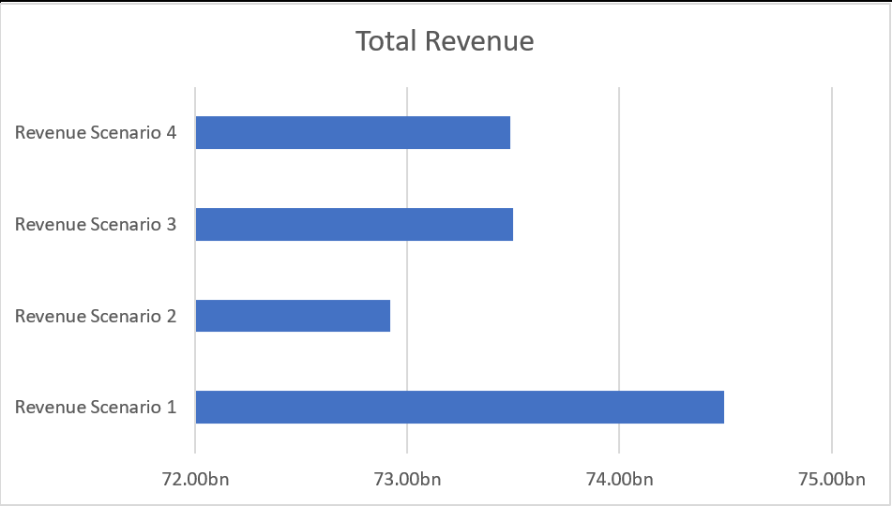

**Conclusion**

The analysis of sales data from January 2014 to June 2015 for the fictitious company has provided valuable insights into the company's revenue streams, regional performance, and market segmentation. The Service Plan line of business emerged as the most significant contributor to overall revenue, with the North East region leading in revenue generation across multiple product lines. However, revenue trends exhibited fluctuations, with notable drops in certain months, particularly during 2014, suggesting potential underlying issues that require further investigation.

The correlation analysis highlighted a weak positive relationship between units sold and revenue, indicating that while increasing sales volume may lead to higher revenue, the impact is not uniformly strong across all products. The presence of high-value outliers, such as the 4500C model, underscores the importance of focusing on premium products that can significantly boost revenue.

The what-if analysis demonstrated that a broad-based increase in units sold (Scenario 1) would yield the most substantial revenue gains, reinforcing the strategy of enhancing sales volume across all models.

**Recommendations**

1. **Focus on High-Performing Regions and Products:** Given the North East region’s strong performance, it is recommended to allocate additional resources to this area, including targeted marketing campaigns and inventory optimization. Emphasizing high-revenue products like the 3002P and 4500C models in these regions could further enhance profitability.
2. **Enhance Sales Volume Across All Models:** Scenario 1 of the what-if analysis showed that a 2% increase in units sold across all models would result in the most significant revenue boost. Implementing strategies such as sales promotions, incentives for the sales team, and expanding distribution channels could help achieve this target.
3. **Investigate and Address Revenue Fluctuations:** The consistent revenue drops observed in 2014 and the sharp decline in April 2015 should be investigated further. Understanding the causes—whether seasonal effects, competition, or operational inefficiencies—will enable the company to develop targeted strategies to mitigate these fluctuations.
4. **Leverage High-Value Trades:** The analysis identified trades with disproportionate revenue impacts, such as the sale of 244 units of the 4500C model. The company should focus on identifying and nurturing high-value customer relationships and consider bundling premium products with other offerings to maximize revenue from each transaction.
5. **Segment-Specific Marketing Strategies:** The performance by trade size indicates varied success across different markets. Developing tailored marketing strategies that cater to the specific needs and purchasing behaviours of each market segment can help optimize sales and improve market share, particularly in underperforming regions like the North Central.
6. **Continuous Monitoring and Adjustment**: Ongoing analysis of sales data should be conducted to track the effectiveness of implemented strategies. Regularly updating the what-if analysis based on the latest data will allow the company to remain agile and adjust its approach to changing market conditions, ensuring sustained revenue growth.